**SMALLEST NUMBER IN AN ARRAY**  
  
**EXP NO: 10**  
**AIM:**To find the smallest number from an array using 8085 processor.  
**ALGORITHM:**  
1)      Load the address of the first element of the array in HL pair.  
2)      Move the count to B register.  
3)      Increment the pointer.  
4)      Get the first data in A register.  
5)      Decrement the count.  
6)      Increment the pointer.  
7)      Compare the content of memory addressed by HL pair with that of A register.  
8)      If carry=1, go to step 10 or if carry=0 go to step 9  
9)      Move the content of memory addressed by HL to A register.  
10)  Decrement the count.  
**PROGRAM:**  
LXI H,2050  
MOV C,M  
DCR C  
INX H  
MOV A,M  
LOOP1: INX H  
CMP M  
JC LOOP  
MOV A,M  
LOOP: DCR C  
JNZ LOOP1  
STA 2058  
HLT  
**INPUT:**

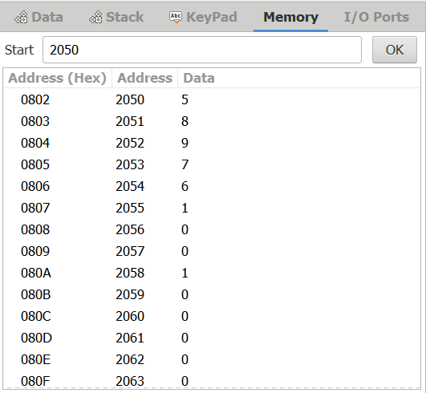

**OUTPUT:**

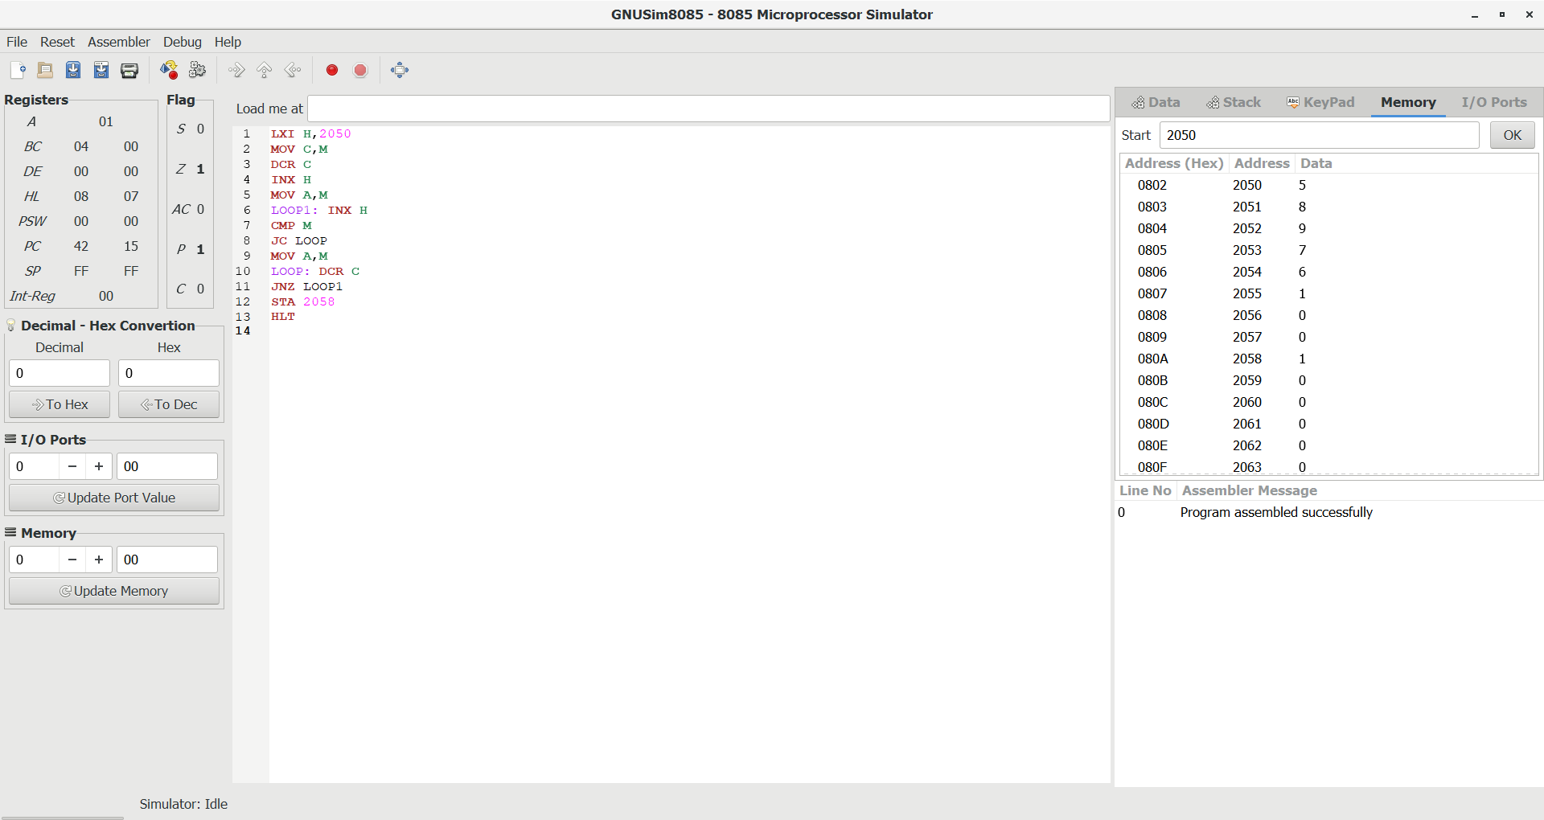

**RESULT: Thus the program was executed successfully using 8085 processor simulator.**